Lab - Reading Server Logs

Objectives
Part 1: Reading Log Files with Cat, More, Less, and Tail
Part 2: Log Files and Syslog
Part 3: Log Files and Journalctl

Background / Scenario
Log files are an important tool for troubleshooting and monitoring. Different application generates different log files, each one containing its own set of fields and information. While the field structure may change between log files, the tools used to read them are mostly the same. In this lab, you will learn about common tools used to read log file and practice using them.

Required Resources
- CyberOps Workstation virtual machine

Instructions

Reading Log Files with Cat, More, Less, and Tail
Log files are files used to record specific events triggered by applications, services or the operating system itself. Usually stored as plain-text, log files are an indispensable resource for troubleshooting.

Opening Log Files.
Log files commonly contain plain-text information which can be viewed by practically any program able to handle text (text editors, for example). However, because of convenience, usability, and speed, a few tools are more commonly used than others. This section focuses on four command-line-based programs: cat, more, less, and tail.
cat, derived from the word ‘concatenate’, is a UNIX, command-line-based tool used to read and display the contents of a file on the screen. Because of its simplicity and it can open a text file and display it in a text-only terminal, cat is widely used to this day.
      - Start the CyberOps Worstation VM and open a terminal window.
      - From the terminal window, issue the command below to display the contents of the logstash-tutorial.log file, located in the /home/analyst/lab.support.files/ folder:
analyst@secOps ~$ cat /home/analyst/lab.support.files/logstash-tutorial.log
The contents of the file should scroll through the terminal window until the all contents have been displayed.

Question:
What is a drawback of using cat with large text files?
Type your answers here.
Another popular tool for visualizing log files is more. Similar to cat, more is also a UNIX command-line-based tool that can open a text-based file and display the file contents on the screen. The main difference between cat and more is that more supports page breaks, allowing the user to view the contents of a file, one page at a time. This can be done using the space bar to display the next page.
      - From the same terminal window, use the command below to display the contents of the logstash-tutorial.log file again. This time using more:
analyst@secOps ~$ more /home/analyst/lab.support.files/logstash-tutorial.log
The contents of the file should scroll through the terminal window and stop when one page is displayed. Press the space bar to advance to the next page. Press enter to display the next line of text.

Question:
What is the drawback of using more?
Type your answers here.
Building on the functionality of cat and more, the less tool allows the contents of a file to be displayed page by page, while also allowing the user the choice of viewing previously displayed pages.
      - From the same terminal window, use less to display the contents the logstash-tutorial.log file again:
analyst@secOps ~$ less /home/analyst/lab.support.files/logstash-tutorial.log
The contents of the file should scroll through the terminal window and stop when one page is displayed. Press the space bar to advance to the next page. Press enter to display the next line of text. Use the up and down arrow keys to move back and forth through the text file.
Use the “q” key on your keyboard to exit the less tool.
      - The tail command displays the end of a text file. By default, tail displays the last ten lines of the file.
Use tail to display the last ten lines of the /home/analyst/lab.support.files/logstash-tutorial.log file.
analyst@secOps ~$ tail /home/analyst/lab.support.files/logstash-tutorial.log
218.30.103.62 - - [04/Jan/2015:05:28:43 +0000] "GET /blog/geekery/xvfb-firefox.html HTTP/1.1" 200 10975 "-" "Sogou web spider/4.0(+http://www.sogou.com/docs/help/webmasters.htm#07)"
218.30.103.62 - - [04/Jan/2015:05:29:06 +0000] "GET /blog/geekery/puppet-facts-into-mcollective.html HTTP/1.1" 200 9872 "-" "Sogou web spider/4.0(+http://www.sogou.com/docs/help/webmasters.htm#07)"
198.46.149.143 - - [04/Jan/2015:05:29:13 +0000] "GET /blog/geekery/disabling-battery-in-ubuntu-vms.html?utm_source=feedburner&utm_medium=feed&utm_campaign=Feed%3A+semicomplete%2Fmain+%28semicomplete.com+-+Jordan+Sissel%29 HTTP/1.1" 200 9316 "-" "Tiny Tiny RSS/1.11 (http://tt-rss.org/)"
198.46.149.143 - - [04/Jan/2015:05:29:13 +0000] "GET /blog/geekery/solving-good-or-bad-problems.html?utm_source=feedburner&utm_medium=feed&utm_campaign=Feed%3A+semicomplete%2Fmain+%28semicomplete.com+-+Jordan+Sissel%29 HTTP/1.1" 200 10756 "-" "Tiny Tiny RSS/1.11 (http://tt-rss.org/)"
218.30.103.62 - - [04/Jan/2015:05:29:26 +0000] "GET /blog/geekery/jquery-interface-puffer.html%20target= HTTP/1.1" 200 202 "-" "Sogou web spider/4.0(+http://www.sogou.com/docs/help/webmasters.htm#07)"
218.30.103.62 - - [04/Jan/2015:05:29:48 +0000] "GET /blog/geekery/ec2-reserved-vs-ondemand.html HTTP/1.1" 200 11834 "-" "Sogou web spider/4.0(+http://www.sogou.com/docs/help/webmasters.htm#07)"
66.249.73.135 - - [04/Jan/2015:05:30:06 +0000] "GET /blog/web/firefox-scrolling-fix.html HTTP/1.1" 200 8956 "-" "Mozilla/5.0 (iPhone; CPU iPhone OS 6_0 like Mac OS X) AppleWebKit/536.26 (KHTML, like Gecko) Version/6.0 Mobile/10A5376e Safari/8536.25 (compatible; Googlebot/2.1; +http://www.google.com/bot.html)"
86.1.76.62 - - [04/Jan/2015:05:30:37 +0000] "GET /projects/xdotool/ HTTP/1.1" 200 12292 "http://www.haskell.org/haskellwiki/Xmonad/Frequently_asked_questions" "Mozilla/5.0 (X11; Linux x86_64; rv:24.0) Gecko/20140205 Firefox/24.0 Iceweasel/24.3.0"
86.1.76.62 - - [04/Jan/2015:05:30:37 +0000] "GET /reset.css HTTP/1.1" 200 1015 "http://www.semicomplete.com/projects/xdotool/" "Mozilla/5.0 (X11; Linux x86_64; rv:24.0) Gecko/20140205 Firefox/24.0 Iceweasel/24.3.0"
86.1.76.62 - - [04/Jan/2015:05:30:37 +0000] "GET /style2.css HTTP/1.1" 200 4877 "http://www.semicomplete.com/projects/xdotool/" "Mozilla/5.0 (X11; Linux x86_64; rv:24.0) Gecko/20140205 Firefox/24.0 Iceweasel/24.3.0"

Actively Following Logs.
In some situations, it is desirable to monitor log files as log entries are written to the log files. For those cases, the tail -f command is very helpful.
      - Use tail -f to actively monitor the contents of the /var/log/syslog file:
analyst@secOps ~$ sudo tail –f /home/analyst/lab.support.files/logstash-tutorial.log

Question:
What is different in the output of tail and tail -f? Explain.
Type your answers here.
      - To watch tail –f in action, open a second terminal window. Arrange your display so you can see both terminal windows. Re-size the windows so you can see them both at the same, as shown in the image below:
The terminal window on the top is running tail -f to monitor the /home/analyst/lab.support.files/logstash-tutorial.log file. Use the terminal window on the bottom to add information to the monitored file.
To make it easier to visualize, select the top terminal window (the one running tail -f) and press enter a few times. This will add a few lines between the current contents of the file and the new information to be added.
      - Select the bottom terminal window and enter the following command:
[analyst@secOps ~]$ echo "this is a new entry to the monitored log file" >> lab.support.files/logstash-tutorial.log
The command above appends the "this is a new entry to the monitored log file" message to the /home/analyst/lab.support.files/logstash-tutorial.log file. Because tail –f is monitoring the file at the moment a line is added to the file. The top window should display the new line in real-time.
      - Press CTRL + C to stop the execution of tail -f and return to the shell prompt.
      - Close one of the two terminal windows.

Log Files and Syslog
Because of their importance, it is common practice to concentrate log files in one monitoring computer. Syslog is a system designed to allow devices to send their log files to a centralized server, known as syslog server. Clients communicate to a syslog server using the syslog protocol. Syslog is commonly deployed and supports practically all computer platforms.
The CyberOps Workstation VM generates operating system level log files and hands them over to syslog.
      - Use the cat command as root to list the contents of the /var/log/syslog.1 file. This file holds the log entries that are generated by the CyberOps Workstation VM operating system and sent to the syslog service.
analyst@secOps ~$ sudo cat /var/log/syslog.1
[sudo] password for analyst:
Feb 7 13:23:15 secOps kernel: [ 5.458959] psmouse serio1: hgpk: ID: 10 00 64
Feb 7 13:23:15 secOps kernel: [ 5.467285] input: ImExPS/2 BYD TouchPad as /devices/platform/i8042/serio1/input/input6
Feb 7 13:23:15 secOps kernel: [ 5.502469] RAPL PMU: API unit is 2^-32 Joules, 4 fixed counters, 10737418240 ms ovfl timer
Feb 7 13:23:15 secOps kernel: [ 5.502476] RAPL PMU: hw unit of domain pp0-core 2^-0 Joules
Feb 7 13:23:15 secOps kernel: [ 5.502478] RAPL PMU: hw unit of domain package 2^-0 Joules
Feb 7 13:23:15 secOps kernel: [ 5.502479] RAPL PMU: hw unit of domain dram 2^-0 Joules
Feb 7 13:23:15 secOps kernel: [ 5.502480] RAPL PMU: hw unit of domain pp1-gpu 2^-0 Joules
Feb 7 13:23:15 secOps kernel: [ 5.672547] ppdev: user-space parallel port driver
Feb 7 13:23:15 secOps kernel: [ 5.709000] pcnet32 0000:00:03.0 enp0s3: renamed from eth0
Feb 7 13:23:16 secOps kernel: [ 6.166738] pcnet32 0000:00:03.0 enp0s3: link up, 100Mbps, full-duplex
Feb 7 13:23:16 secOps kernel: [ 6.706058] random: crng init done
Feb 7 13:23:18 secOps kernel: [ 8.318984] floppy0: no floppy controllers found
Feb 7 13:23:18 secOps kernel: [ 8.319028] work still pending
Feb 7 14:26:35 secOps kernel: [ 3806.118242] hrtimer: interrupt took 4085149 ns
Feb 7 15:02:13 secOps kernel: [ 5943.582952] pcnet32 0000:00:03.0 enp0s3: link down
Feb 7 15:02:19 secOps kernel: [ 5949.556153] pcnet32 0000:00:03.0 enp0s3: link up, 100Mbps, full-duplex

Question:
Why did the cat command have to be executed as root?
Type your answers here.
      - Notice that the /var/log/syslog file only stores the most recent log entries. To keep the syslog file small, the operating system periodically rotates the log files, renaming older log files as syslog.1, syslog.2, and so on.
Use the cat command to list older syslog files:
analyst@secOps ~$ sudo cat /var/log/syslog.2
analyst@secOps ~$ sudo cat /var/log/syslog.3
analyst@secOps ~$ sudo cat /var/log/syslog.4

Question:
Can you think of a reason why it is so important to keep the time and date of computers correctly synchronized?
Type your answers here.

Log Files and Journalctl
Another popular log management system is known as journal. Managed by the journald daemon, the system is designed to centralize the management of logs regardless of where the messages are originating. In the context of this lab, the most evident feature of the journal system daemon is the use of append-only binary files serving as its log files.

Running journalctl with no options.
      - To look at the journald logs, use the journalctl command. The journalctl tool interprets and displays the log entries previously stored in the journal binary log files.
analyst@secOps ~$ journalctl
-- Logs begin at Fri 2014-09-26 14:13:12 EDT, end at Tue 2017-02-07 13:23:29 ES
Sep 26 14:13:12 dataAnalyzer systemd[1087]: Starting Paths.
Sep 26 14:13:12 dataAnalyzer systemd[1087]: Reached target Paths.
Sep 26 14:13:12 dataAnalyzer systemd[1087]: Starting Timers.
Sep 26 14:13:12 dataAnalyzer systemd[1087]: Reached target Timers.
Sep 26 14:13:12 dataAnalyzer systemd[1087]: Starting Sockets.
Sep 26 14:13:12 dataAnalyzer systemd[1087]: Reached target Sockets.
Sep 26 14:13:12 dataAnalyzer systemd[1087]: Starting Basic System.
Sep 26 14:13:12 dataAnalyzer systemd[1087]: Reached target Basic System.
Sep 26 14:13:12 dataAnalyzer systemd[1087]: Starting Default.
Sep 26 14:13:12 dataAnalyzer systemd[1087]: Reached target Default.
Sep 26 14:13:12 dataAnalyzer systemd[1087]: Startup finished in 18ms.
Sep 26 14:14:24 dataAnalyzer systemd[1087]: Stopping Default.
Sep 26 14:14:24 dataAnalyzer systemd[1087]: Stopped target Default.
Sep 26 14:14:24 dataAnalyzer systemd[1087]: Stopping Basic System.
Sep 26 14:14:24 dataAnalyzer systemd[1087]: Stopped target Basic System.
Sep 26 14:14:24 dataAnalyzer systemd[1087]: Stopping Paths.
Sep 26 14:14:24 dataAnalyzer systemd[1087]: Stopped target Paths.
Sep 26 14:14:24 dataAnalyzer systemd[1087]: Stopping Timers.
Sep 26 14:14:24 dataAnalyzer systemd[1087]: Stopped target Timers.
Sep 26 14:14:24 dataAnalyzer systemd[1087]: Stopping Sockets.
<output omitted>
Note: Running journalctl as root will display more detailed information.
      - Use CTRL+C to exit the display.

Journalctl and a few options.
Part of the power of using journalctl lies in its options. For the following commands, use CRTL+C to exit the display.
      - Use journalctl --utc to display all timestamps in UTC time:
analyst@secOps ~$ sudo journalctl -–utc
      - Use journalctl -b to display log entries recorded during the last boot:
analyst@secOps ~$ sudo journalctl –b
Feb 07 08:23:13 secOps systemd-journald[172]: Time spent on flushing to /var is
Feb 07 08:23:13 secOps kernel: Linux version 4.8.12-2-ARCH (builduser@andyrtr)
Feb 07 08:23:13 secOps kernel: x86/fpu: Supporting XSAVE feature 0x001: 'x87 fl
Feb 07 08:23:13 secOps kernel: x86/fpu: Supporting XSAVE feature 0x002: 'SSE re
Feb 07 08:23:13 secOps kernel: x86/fpu: Supporting XSAVE feature 0x004: 'AVX re
Feb 07 08:23:13 secOps kernel: x86/fpu: xstate_offset[2]: 576, xstate_sizes[2]
Feb 07 08:23:13 secOps kernel: x86/fpu: Enabled xstate features 0x7, context si
Feb 07 08:23:13 secOps kernel: x86/fpu: Using 'eager' FPU context switches.
Feb 07 08:23:13 secOps kernel: e820: BIOS-provided physical RAM map:
<output omitted>
      - Use journalctl to specify the service and timeframe for log entries. The command below shows all nginx service logs recorded today:
analyst@secOps ~$ sudo journalctl -u nginx.service --since today
      - Use the -k switch to display only messages generated by the kernel:
analyst@secOps ~$ sudo journalctl –k
      - Similar to tail -f described above, use the -f switch to actively follow the logs as they are being written:
analyst@secOps ~$ sudo journalctl –f

Reflection Question
Compare Syslog and Journald. What are the advantages and disadvantages of each?

Lab Answers
Part 1
- Step 1
  - Screenshot showing logstash-tutorial.log opened using cat
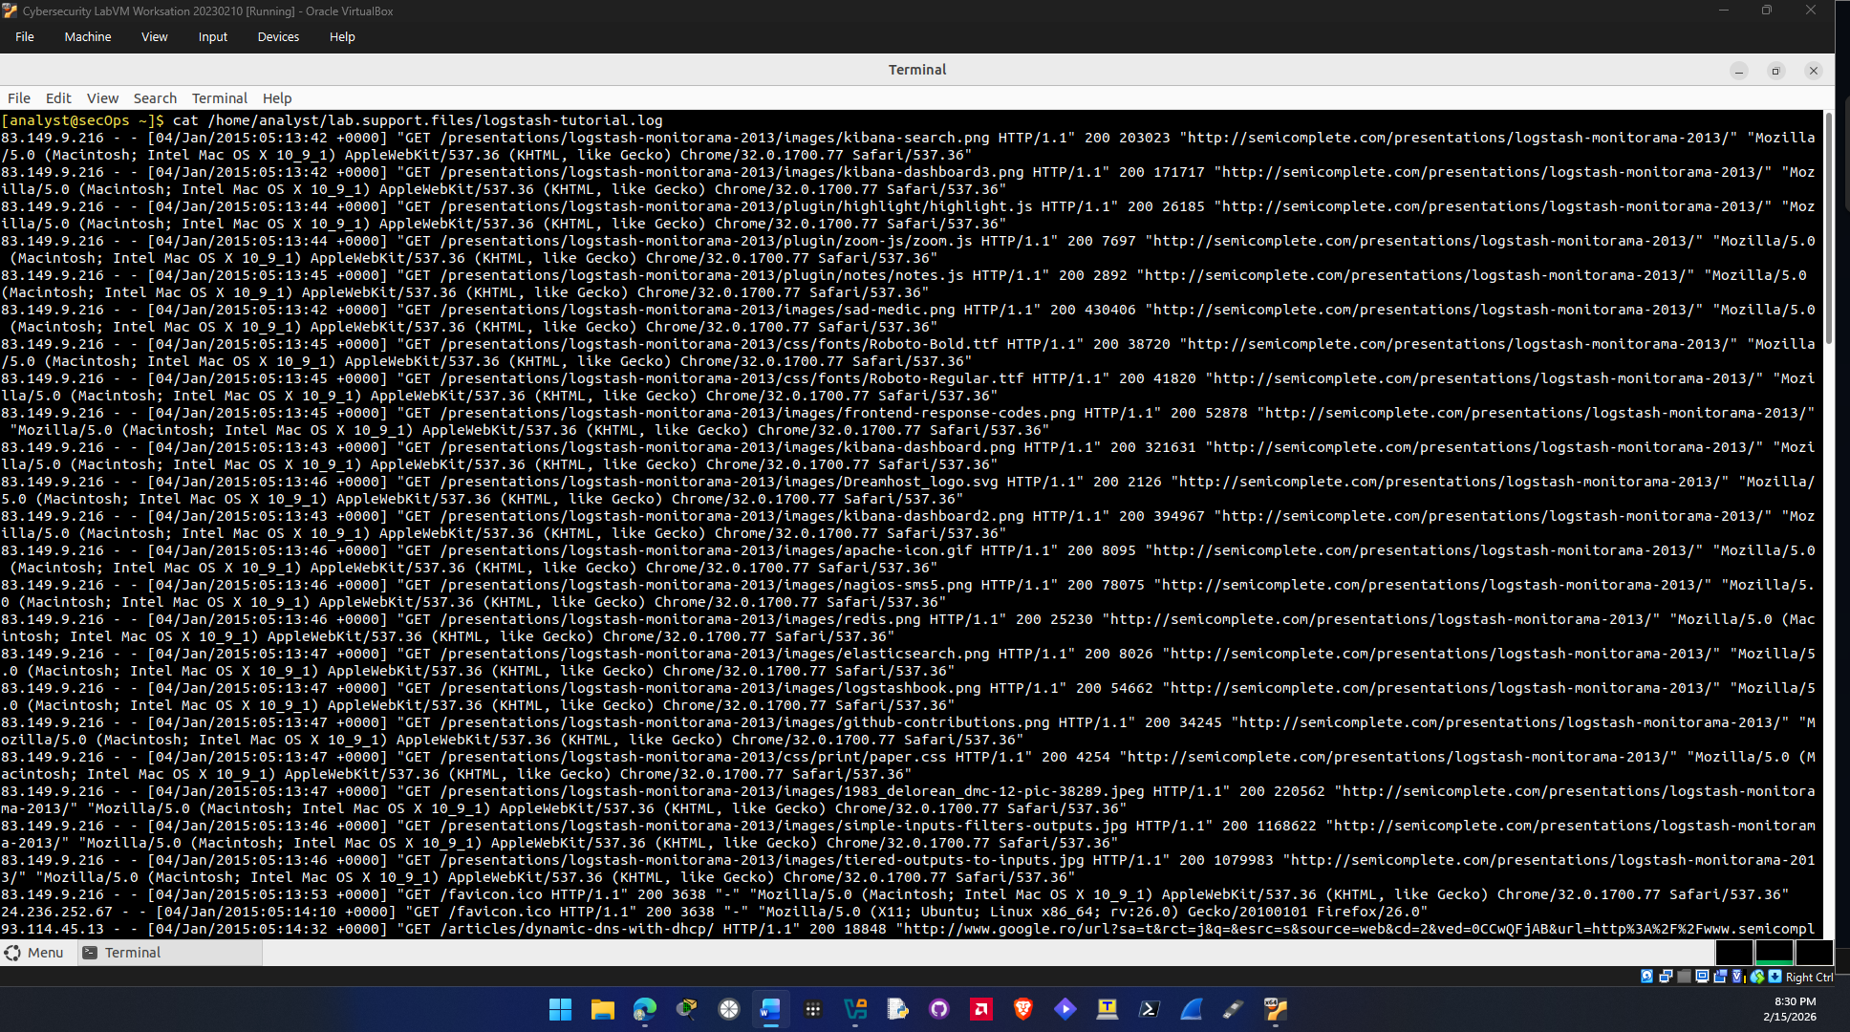
Question b.
The drawback of using cat with large files is that the format is a little messy when looking at the logs and if you need to find a specific log line it would be hard to do that.

Question c.
The drawback of using more is no search functionality and not being able to scroll back up it just displays the next line after hitting enter again.

- Step 2
  - Screenshot showing tail command executed
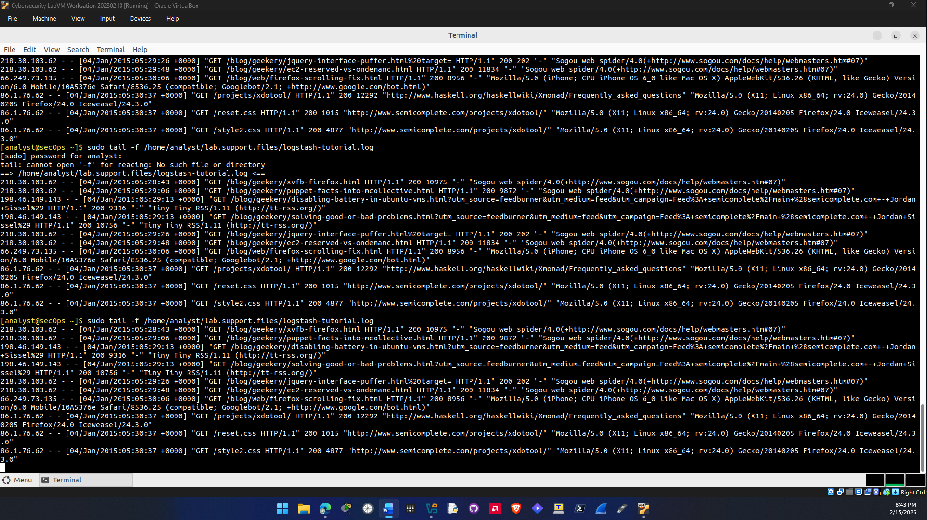
Question a.
The difference between the output of tail and tail -f is that -f locks the terminal so it cant accept anymore commands because its still running and actively watching for any write changes to the log file.
Part 2
- Step 1
  - Screenshot showing var/log/syslog.1 file is read
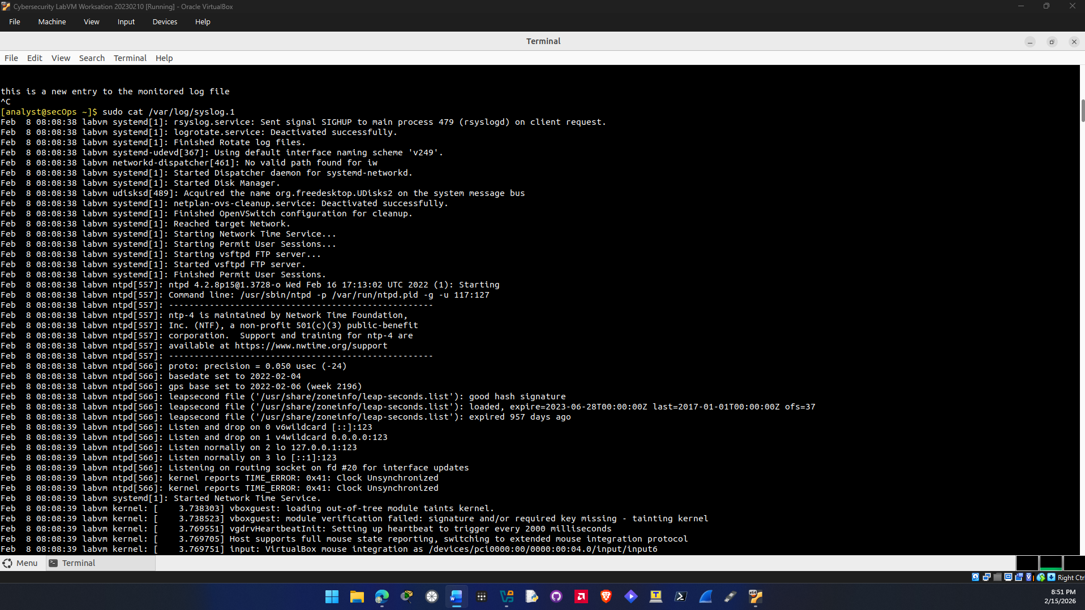
Question a.
The cat command had to be executed as root because /var/log/syslog belongs to root and can only be read by root. If you tried to do it as any other user it would not work.

Question b.
It’s important to keep the time and date of computers synchronized because log systems need to use It to recored the time date and time a specific event happened. If the system clock is not correct then it would make it difficult to troubleshoot when looking at logs.

Part 3
- Step 1
  - Screenshot showing journalctl command executed
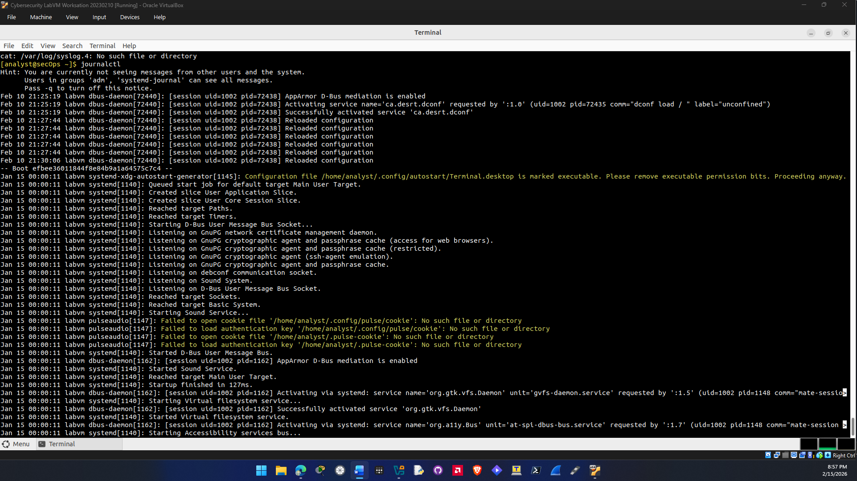

Reflection Question
Syslog is a solution for logging. It uses plain text files without any structure, and the information is not centralized this means that you have to search through information to find the relevant information you actually want in the logs. It also does not have a way to separate different application log messages it just groups them all together. Journald has file formatting for log messages which makes it significantly easier to read log files and find relevant log messages that you are looking for or may want.

